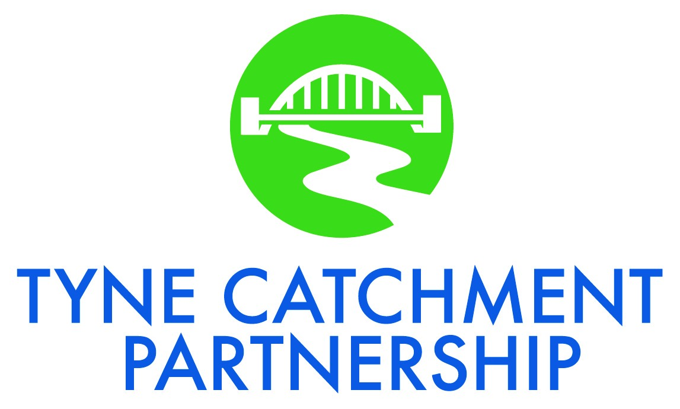

Working together to benefit the people, wildlife and habitats of the Tyne Catchment’s river environments

Activity Plan

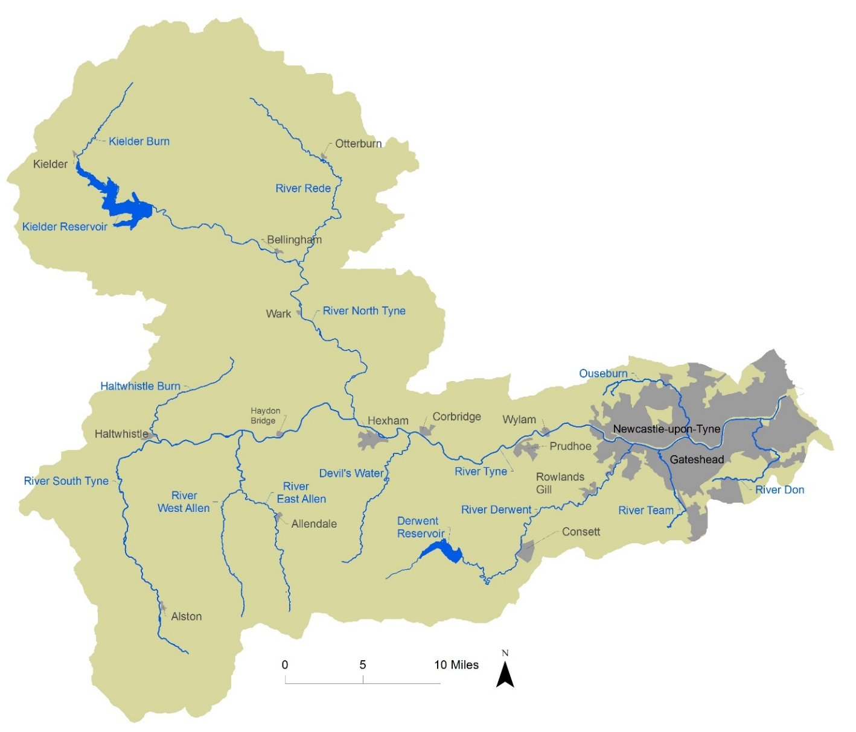
The catchment area of the River Tyne, and operational area of the Tyne Catchment Partnership
Contents
Our Vision 1
Our Objectives 1
Aims of this Plan 1
Current and Future Partnership Activity 1
Monitoring Progress 4
Appendix 1: Tyne Catchment Partnership Terms of Reference 5
Appendix 2: Priority Issues and Locations 7

The Tyne Catchment Partnership formed in 2012 and operates in line with Defra’s Catchment-based Approach. There are currently 22 partner members. The Partnership’s Terms of Reference are set out in Appendix 1.

Our Vision
Working together to benefit the people, wildlife and habitats of the Tyne Catchment’s river environments.

Our Objectives
- Promoting and celebrating partners’ achievements and successes
- Identifying and grasping needs and opportunities to work together for better outcomes for the River Tyne and its people
- Speaking with a single voice where partners’ interests overlap in managing and improving the River Tyne
- Grasping opportunities for projects to deliver multiple benefits for the benefit of the River Tyne
- Using resources to best effect and coordinating activities on a catchment and sub-catchment level.

Aims of this Plan
This Activity Plan aims to identify issues and places which the Partnership and its individual members will focus on. It is not an exhaustive list of all the relevant activity going on in the catchment, but seeks to identify work which will ‘fill the gaps’ between current river improvement activities and bring together partners to work collaboratively to resolve problems on both a geographic and an issues basis.
The Activities that have been, are being, and will be undertaken are recorded in the Partnership’s Activity Log, a working document which is continually updated as the Partnership carries out its activities.

Current and Future Partnership Activity
In December 2014 the Partnership carried out a gap analysis exercise to identify all the work currently going on in the Tyne catchment, compared these against the known issues, and identified the gaps where activity is needed but not being undertaken (see Appendix 2 for details). Below is a high-level summary of the issues and locations where the Partnership has identified it could/should fill the gap in identifying and delivering solutions.
A detailed summary of past, current and proposed future Partnership activity is set out in the Activity Log, a separate working document which is continually updated.

Ouseburn Catchment
  - Continue to implement the measures from the Ouseburn Evidence & Measures project as opportunities arise. Link with Environment Agency’s Ouseburn River Restoration project (being delivered by Groundwork & partners), Newcastle University’s Urban Observatory project, Northumbrian Water Group’s PR19 planning, and Tyne Rivers Trust’s Countryside Stewardship Facilitation Fund programme with farmers.
  - Develop future funding bids for conservation and monitoring activities.
  - Continue to engage with developers to ensure river and flooding issues are appropriately addressed in development proposals.

River Don Catchment
  - Continue to develop proposals for the River Don, bringing together the findings from the South Tyneside Council Feasibility Study, Environment Agency walkover survey results, Northumbrian Water Group’s Misconnection Project etc, to develop holistic proposals for river improvements using ear-marked Environment Agency and Tyne Rivers Trust funds.
  - Seek future funding for improvement work: HLF Landscape Partnership bid or similar; Northumbrian Water Group’s PR19 planning.
  - Continue to engage with developers, particularly in relation to the IAMP development and Follingsby Park South.

River Team Catchment
  - Bring together a Partnership sub-group to further develop proposals, complementary to and building on the flood alleviation and habitat creation scheme and other work currently being undertaken by Gateshead Council and the Environment Agency.

Greenlee, Broomlee & Crag Lough (SSSI Lake Waterbodies)
  - On-going monitoring needed to understand effectiveness of recent measures and identify appropriate further interventions.
  - Bring together a Partnership sub-group to further develop proposals, seek the reasons for failing to be classified as having good WFD status and build closer partnerships for the area.

Blaydon Burn
  - Press for more water quality monitoring to pick up historic issues (suspected contaminated land, landfill leachate); challenge WFD ‘good’ status and lack of ‘heavily modified’ designation.
  - Develop proposals for river improvement and better engagement of communities with the industrial and natural heritage of the site – potential site for a future Heritage Lottery Fund bid.

South Tyne
  - Bring together a Partnership sub-group to further develop proposals, build on the existing metals work, Facilitation Funds and develop partnerships in this area.

Tyne Estuary Improvements
  - Develop a Tyne Estuary Plan to improve ecology and green/blue infrastructure
  - Seek funding for a feasibility to identify options around estuary edges on this heavily modified river
  - Engage with developers and land owners along the estuary to incorporate modifications to naturalise the estuary edges and create green/blue infrastructure.
  - Look for opportunities with Natural England to designate parts of the estuary e.g. SSSI for birds

Community activities (not location specific)
  - Strengthen community activity through volunteering programmes, including joint tasks between partners running volunteer activities (Tyne Rivers Trust, Durham Wildlife Trust, Northumberland Wildlife Trust, Groundwork, Northumbrian Water’s Water Rangers, Northumberland National Park Authority, National Trust and local authorities).
  - Improve community engagement with rivers, improve the geographic extent of ‘citizen science’ monitoring, and increase reporting/addressing of issues through the Adopt-a-Stream project (in development).

Species-specific activities
  - Develop a catchment-wide programme to map and tackle invasive species – potential to link with neighbouring catchments across the headwaters.
  - Build on the Freshwater Pearl Mussel Steering Group’s efforts to conserve FWPM and its habitat including:
- bringing the “ark” from Windermere to the Kielder Hatchery, to increase breeding success and improvements for fish and for freshwater pearl mussel.
- identifying and preparing habitat for the return of captive-bred mussels to the Rede and N Tyne, including channel capacity management to repair modified stretches.
  - Continue to address in-stream barriers to fish movement/migration; partners to support Tyne Rivers Trust’s ongoing programme by identifying sites for improvement (e.g. culverts, bridge footings, fords), influencing developers to maintain day lighted channels and river connectivity. Partnership to engage with Highways England to develop rolling programme of improvement works.

Heavy metal and legacy mining issues
  - Partnership to add its weight to argument for continued funding of current point-source and diffuse-source remediation programmes.
  - Sub-group to continue to meet and look into wider impacts of mining legacy, primarily in the South Tyne, Allen Valleys and River Derwent but including impacts through to the estuary and with a link to flooding. Look at impacts on businesses (including agriculture), human health, and the wider environment, with a view to widening the current metals programme and seeking funding, e.g. for upstream natural flood management measures, and a better understanding of the holistic ‘cost’ of legacy mines and flooding.

Flooding
  - Continue to seek funding for natural flood management (NFM), based on projects list put forward for funding in 2017.
  - Sub-group to meet to look at wider opportunities for Partnership involvement / lead on NFM projects and community engagement and awareness work.

Sustainability of the Partnership
  - Partners to include funding for the Partnership in relevant funding bids, ideally to fund a part-time person.

Monitoring Progress
Progress against this Plan will be reviewed by the Partnership on an annual basis and, if resources permit, it will be updated to reflect the developing priorities of the Partnership.

Appendix 1: Tyne Catchment Partnership Terms of Reference
These Terms of Reference are for the guidance of current or potential Partners (members) and are designed to outline what the Tyne Catchment Partnership (the ‘Partnership’) is all about and how it is intended to work.

Our Vision
Working together to benefit the people, wildlife and habitats of
the Tyne Catchment’s river environments
The Partnership seeks to become a key influencer and supporter of decisions by any organisation or agency proposing work to improve our rivers and their catchments. As an unconstituted body, our primary role in delivery is to facilitate organisations, as individuals or groups, to identify, develop, seek funding for and then deliver projects.
Whilst we seek to develop strategic partnerships to which all partners can sign up, we recognise that individual partners will have their own complementary priorities. We recognise and accept this and encourage transparency from partners where and when this happens. The Partnership will operate on a collaborative basis and will seek to avoid competition for resources. We are happy in principle to support any work by any partner improving the rivers or land within the Tyne catchment area.

Objectives (achieving our vision)
- Promoting and celebrating partners’ achievements and successes
- Identifying and grasping needs and opportunities to work together (as organisations) for better outcomes for the River Tyne and its people
- Speaking with a single voice where partners’ interests in managing and improving the River Tyne overlap
- Grasping opportunities for projects to deliver multiple benefits for the benefit of the River Tyne
- Using resources to best effect and coordinating activities on a catchment and sub-catchment level
Our common objectives include improving the water environment for people and for the natural environment. They include an element of multi-functional benefits and green infrastructure, and of seizing opportunities to work together and make the best use of resources.

Host and Chair
Hosting / co-ordination of the Partnership is provided by Tyne Rivers Trust. Our current Chair is Hugh Clear-Hill, who formerly represented Northumberland County Council on the Partnership, and is a Trustee of Tyne Rivers Trust. Meeting venues are not fixed, but move around, according to the agenda and offers of partners hosting the meeting. Feedback on the hosting role is welcome at any time.

Membership
There are currently 22 member organisations www.tynecatchment.org representing groups and organisations that have a direct relationship with Tyne river catchment issues. Members are:
- representatives of key stakeholder organisations whose interests lie in maintenance or improvement of the aquatic environment and the catchment
- knowledgeable in their field and able to offer advice, resources (such as data, information, access to other groups) and practical support
- willing to actively speak about the interests of their sector in discussions
- able to exert influence on behalf and within their organisation and are in a position to facilitate project delivery / work agreed by the Partnership
- aware and understanding about other partners’ views and are willing to listen, communicate and respect each other.
New members can request to join the Partnership at any time. Members are expected to:
- commit time to attend meetings and be prepared by seeking information from within their own organisation if necessary. If sending a deputy, they should be fully briefed before the meeting
- represent the Tyne Catchment Partnership at other meetings where relevant and appropriate.

Meetings
The Partnership meets around 3-4 times a year. Meetings include an element of professional networking, co-ordination of activities, raising awareness of issues across the catchment, and joint input into consultations. Meetings have two fundamental and complementary purposes: (1) action planning and raising awareness of existing projects and initiatives, and (2) development of existing and new partnerships and collaboration.
Notes are taken and are published on the Tyne Catchment Partnership website.
Agenda items for future meetings are welcome at any time. Where possible the Agenda and papers will be circulated at least one week before the meeting.

Decision making
Decisions are made by majority voting of those present at a meeting where a vote is called for, or by online ballot outside of a meeting. Each organisation represented at the meeting is restricted to a single vote.

Legal status
The Partnership is an unconstituted voluntary body. Its area of operation is the Tyne catchment. The Partnership has no legal status.

Appendix 2: Priority Issues and Locations
In December 2014 the Tyne Catchment Partnership carried out a gap analysis exercise to identify all the work currently going on in the Tyne catchment, compared these against the known issues, and identified the gaps where activity is needed but not being undertaken. The lists below are far from exhaustive, but are issues or locations which the Partnership agreed are a priority. Where the Partnership has identified a gap which it can fill this is listed in the Current and Future Partnership Activity section which starts on page 2.

South Tyne
- The mines and minerals issue is the main problem in this area – a number of initiatives are tackling this but it is a huge issue with impacts throughout the catchment, and work must also consider the needs of protected Calaminarian grasslands. Recently a small sub-group has started to look at the heavy metal contamination issue from a wider perspective, bringing in elements of human health, in addition to the impact on river ecosystems.
- ‘General’ pollution is less of a priority, apart from the Roman Wall Loughs which may still have management issues or need for monitoring.
- Invasive Species are not a Water Framework Directive (WFD) driver but are of concern, especially to local people. A co-ordinated approach to invasives is a good priority for the Partnership.
- There are localised urban flooding issues (Haltwhistle / Acomb), although some parts of the catchment are very rural. The impacts of flooding (particularly winter 2015) on agricultural land has not been well quantified. A proposal to address downstream flood risk (at Haydon Bridge, Hexham and Corbridge) through landscape-scale Natural Flood Management (NFM) implementation has been mooted, but finding funding would be difficult.
- Fishery issues are linked to heavy metal pollution and man-made and natural structures.

North Tyne
- Kielder forestry impacts are reflected in WFD monitoring; some problems were being addressed by the Tyne Forest Streams project (which has recently finished) but it is difficult to judge to what extent the project will have addressed the issues in the short-term
- The Kielder area currently has a water vole reintroduction project in place. Northumberland Wildlife Trust has ambitions for beaver reintroduction which could alleviate flood problems / slow the flow as well as have potential for eco-tourism. There is likely to be under-reporting / under-monitoring of biodiversity issues in this area as it is so rural. There are unconfirmed reports of signal crayfish on the North Tyne.
- Generally flood maps only show part of the problem – the ‘flood warnings’ data is only for the main river, not for ordinary watercourses nor for surface water flooding. It is difficult to ‘warn’ for surface water flooding at the moment but there are maps and work has been started with the community at Bellingham & Tarset for example.

Main Tyne (Watersmeet to Estuary)
- The biggest problem on urban rivers is the complexity of the issues and trying to ‘unpick’ the principal source or sources of problems in any given reach. Initiatives which bring together multiple partners (like the Evidence & Measures approach to obtaining consensus on Ouseburn issues and remedies) is a key activity for the Partnership – in addition to ongoing work on the Ouseburn there is a developing Partnership project on the River Don, and the River Team is in the Partnership’s sights.
- There is concern that the WFD status of ‘good’ for Blaydon Burn is not accurate and needs further investigation.
- Invasive species are a big problem on the main Tyne, with Giant hogweed now present and Himalayan balsam preventing public access to rivers in high summer. There are Signal crayfish on the Derwent.

