Ouseburn E&M meeting, Ouseburn Farm
Tuesday 13 October 2015

Abi Mansley, Tyne Catchment Co-ordinator
Susan Mackirdy, Director, Tyne Rivers Trust
Rob Carr, EA
Graeme Hull, EA
John Robinson, NCC
Andrew Holmes, N Tyneside Council
Andy Large – NIRES (Institute for Sustainability)
Emma Craig, NWT
Clare Deasy, NWG
Paul Muto, NE

Remit of group – continuing on from E&M workshops – seeing measures through
JR: Opportunity to deal with these issues because so much going on (sewers, agriculture) useful to have this group as an advisory group for planning side of things – a point where we can talk about what will go on – need to get it right this time around (we are now putting things right that have happened in the past) – a useful forum, meeting new people / colleagues and making useful links. Multiple benefits.
AH: frequency of meetings – allow enough time for progress to happen but every 8-12 weeks feels about right.
JR: Planning proposals are going ahead – nothing firm in yet.
Note – by being part of this group there is a commitment at an organisational level to the Ouseburn work; and each person around the table is responsible for finding a representative to attend any meeting, if they are unavailable.
Recap -
Briefing note – circulated by CD – words are right but not the look. Not branded to NWG. CD asked for comments on layout – maps need some more detail (place names etc). Boundary between local authorities. Urban area.
Defra – v. positive meeting, with Victor Aguilera, showed him the briefing note. Match funding, talked about efficiencies and MTP (current bid in both to extend the approach to Don and Team and the expertise into the region; and to see the Ouseburn measures through. The MTP match could come from Defra or from other grants that the TRT could apply for, as a charity). Victor thanks everybody for their involvement with the Ouseburn project and all the in-kind time that has been put in. He is greatly encouraged how we are all working together and making new professional links. Delighted that we grabbed the opportunity to use the Evidence & Measures methodology in this area.
Wider Ouseburn meeting – planned for 19 November, about reporting on Evidence & Measures project, EA’s river restoration project, update on planning issues. Developing a VISION
Post E&M survey – circulated – thanks to everyone who filled it in. Abi will circulate this electronically
Any other activity to report on since July:
JR – close to signing off surface water management plan (end of year)
NWT – completed habitat works (floating islands) from NWG’s Branch Out funds
Actions/measures from the workshop
Planning / Development
NTC – about to finalise Local Plan (Nov), which references this work, wider evidence base being updated, opportunity to include measures in green infrastructure strategy (especially reach 5 is N Tyneside), links to SuDS, difficult to agree guidance amongst LAs. Andrew Holmes can update the wider Ouseburn group on this on 19th Nov.
Need to develop a habitat/environment vision for the Ouseburn – if referenced in the Local Plan (even as an ‘emerging’ strategy) then it becomes a key action for developers to adhere to. Task and finish group to achieve this (has been done for the River Don by the LNP – approach Jim Cokhill to see if we can use theirs as a basis) plus potentially other Strategic overview group actions (eg. check-list and links to guidance for developers, consider scorecards for individual developments). Action SM to get group together. Need to include lead local flood authority (help!) and ecologists from each Local Authority.
Reducing surface water inputs – happening as a matter of course in both NTC and NCC areas. Moving action because in some areas waiting for developers to submit master plans.
Developer guidance had been worked up in some detail by Gateshead Council – need to pick this up again. A lot of the document was about SUDs but each local authority has a different approach to this. Rob sent links to Cameron. Sue sent information to Susan. Action: John Robinson & Andrew Holmes to look into how Newcastle City Council and North Tyneside Council are using this document and report back.
S106 agreements have to be (these days) closely tied to the development itself.
Agricultural / rural measures
There are approx 10 farms in the rural part of the catchment (see map below), all in Entry Level Stewardship. Bad practice regarding manure heap management can be followed up with a farmer at any time, it is not about waiting for a new agreement.
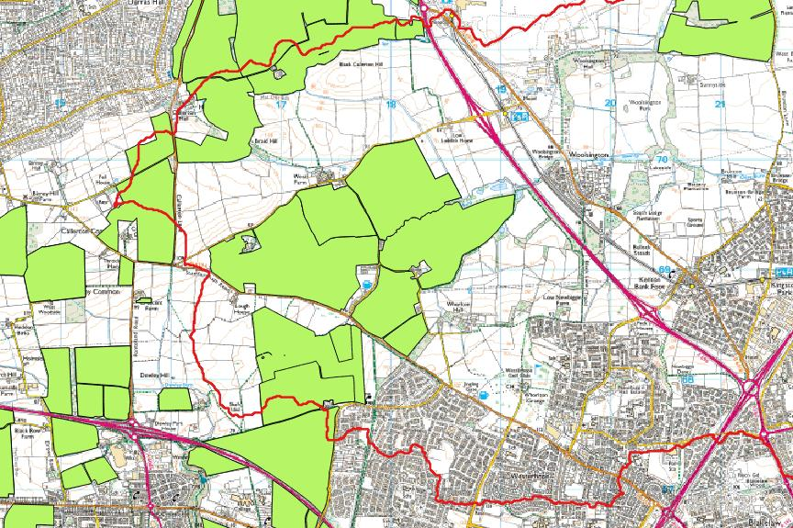
Soil testing / sediment testing / working with farmers and golf course / race course managers – EA could do farmer / golf course visits (general farm advice) as “business as usual” with NE. Ouseburn needs to become a focus catchment for NE to put in resource – SM working on trying to make this a priority for NE – at moment engagement is a bit tenuous – a lot of potential – having assurance that EA would back this up would be helpful. EA has Ouseburn down as a priority - can focus agricultural teams on this but would be good to speak with NE to coordinate activities (reduce NE resource inputs). EA had new guidance for farmers. Action RC/PM to bring relevant EA/NE people together ideally for action early 2016; SM to influence NE managers to give PM the go-ahead.
EA has internal briefing for their priority areas (including the Ouseburn) – RC/GH will approach Robert Brotherton about influencing his contacts at NE to raise the priority of Ouseburn within NE and bring to WFD Liaison Panel members to bring the members on board, e.g. NFU.
Additional soil / sediment testing is not “business as usual” so not currently covered – need to find out general costs for this work so we can work into a bid for funding and resources. Group agreed to do this now (not wait for CSF reprioritisation in 2017) because of risks of waiting and also delays in getting benefits to the water environment. This project shouts for a green infrastructure approach - SuDS, development, rainwater runoff, slow the flow, NFM, new developments zero discharge, recreation space as an add-on. Needs resource to develop a plan – good candidate for Ouseburn action funding (if successful from EA’s MTP)?
Natural England’s priority on Green Infrastructure work seems to be in flux.
EA could provide fertiliser management guidance with all greenkeepers / race courses in the catchment (so start this action straight away, instead of investigating then doing) – Action Rob Carr / Graeme Hull
Masters projects – Andy Large will follow up.
Waste water group
Killingworth / Longbenton Letch work going ahead. Assumption that quality of surface water that will be redirected will be good – needs WQ monitoring (wish list).
Research/investigation on the Ouseburn – task and finish group – CD will lead on setting this up. Suite of research ideas that could be co-ordinated, some could be done by Uni students. Emma Craig has some data from Natural History Society on WQ information on the Whitecroft Burn (fed from an industrial estate – where Killingworth input will be) – WQ leaving Gosforth Park better than that going in, but some eutrophication in main lake (from racecourse?). More data needed here. Racecourse looking at an all-weather surface – link to agricultural / golf course / race course type visits.
Big build up of nutrients in the Gosforth Lake?
EA monitoring is v hard to get now because of budget cuts – building what the Ouseburn needs into a wider research project would be beneficial. All the ‘misconnections’ type actions on the spreadsheet need resources / prioritisation. There are regular meetings between EA and NWG. NWG misconnections funding is limited – need to be careful that all resources go to the Ouseburn and leave other areas with none. RC/CD will raise the Ouseburn at Michael Porritt’s (Northumbrian Water Group) meeting on wrong connections / misconnections (which takes place ~every 2 months). Awareness raising is important – linked to capital investment – works well. Link to Living Waterways funding unlikely. Wrong connections cost effectiveness – sometimes ‘end of pipe’ solutions are better than ‘source’. SuDS end-of-pipe solutions plus awareness-raising is a successful approach. RC will find out more about attenuation mattresses (UU trials), including costs.
Any Other Business
Victor at Defra encouraged the group (via Susan) to keep in mind the online resources on the CaBA website – contains the latest innovations/thinking/tools. Demonstration Test Catchments. Abi to look at the CaBA resources online to see whether there are any useful ones that are applicable to the Ouseburn and feedback to next meeting.
CD/RC will share Ouseburn briefing note at CaBA workshop on urban issues next week and will feed back to the Tyne Catchment Partnership. RC is attending the one in Lancaster (citizen science) and will get a water quality monitoring kit for the Tyne Catchment Partnership.
Andy Large might be able to find a room at Newcastle Uni for the wider Ouseburn meeting on 19th Nov. SM invited anyone else to help present on the E&M project.
Proposal to use Defra £3k for setting up evaluation (not monitoring) of the implementation and effectiveness of the measures agreed at the workshop, and include measuring wider ecosystem benefits of addressing the P issues on the Ouseburn. Wider benefits / ecosystems services benefits (more than water quality but also benefits to wider society). Rob has some papers – he will circulate to Nick & Paul. SM to inform Paul/Victor.
How to ‘brand’ this next phase of the project.
Environment Report Cards – Maryland project – useful for community involvement or developer involvement (for visualising). Can be found by looking for “Integrated Application Network” online.
Need to identify priorities for measures (not necessary linked to timescales) – All to send Abi high, medium and low priorities of list of measures to allow her to add to the spreadsheet. Add another column (timescales, priorities).
Next meeting would be in January? Abi set date and organise

Note – there are many ideas how to make the process “leaner” when it is run again in the Don and the Team. An early technical group could meet to examine the evidence closely, which would save time at the first workshop, for example.

