Minutes from Tyne Catchment Partnership Meeting

8th December 2015

Natural England Offices, Newcastle

Present
Susan Mackirdy (Tyne Rivers Trust), Jackie Hunter (N Tyneside Council), Derek Hilton-Brown (Newcastle City Council), Graeme Hull (Environment Agency), Clare Deasy (Northumbrian Water Group), Jim Cokhill (Durham Wildlife Trust), Peter Bell (Gateshead Council), Kirsty McNaught (Tyne Rivers Trust), Michelle Hogg (S Tyneside Council), Lynne Dunleavey (Regional Flood Coastal Committee), Sarah Beeson & Naomi Waite (Northumberland Wildlife Trust), Monique Speksnyder (Natural England), Abi Mansley (Tyne Rivers Trust)

Apologies
Angus Collingwood-Cameron (Northern Farmers & Landowners Group), Hugh Clear-Hill (Northumberland County Council), John Robinson & Lindsay Bramwell (Newcastle City Council), Andrew Miller (Northumberland National Park Authority), Tony Hanson (S Tyneside Council), Tom Dearnley (Forestry Commission), Dorothy Fairburn (CLA), Tony Baines (Northumbrian Water Group), Adele Rowe (Natural England)

Actions / updates from last meeting
- Following the presentation on Water Rangers, Abi has sent details of partners who run volunteer groups to Helen and Pam from NWG
- Clare apologises for the delay in letting partners know the results of the NWG funding offer. The delay is due to industrial action. Internal meetings have taken place and she will be able to let partners know soon.
- Blaydon Burn – Third Party evidence can be sent to Graeme Hull in January / February to put into a folder for the investigations team when they come to assess the (new) waterbody. (In fact evidence about any waterbody can be sent, not just Blaydon Burn). This would include any evidence about pollution or physical modifications / heavy modifications (dams, culverts etc.)
- Developing a logo for the partnership : still being progressed between Abi and Clare Deasy

Presentation – Calaminarian Grasslands
Abi and Naomi presented on the topic of calaminarian grasslands. These are alluvial shingle deposits that are contaminated from the historic mining of lead, silver, zinc etc. Waste from the ore dressing process were released and deposited downstream as fine sediment trapped between cobbles. These shingle areas become exposed and are colonised by plants which are tolerant of the heavy metals. They benefit from a lack of competition from other plants. In fact, the metals build up in the plant and are part of its natural insecticide defences. The habitat is a dynamic one and is thought to be in decline. Some of these special plants would have been used by mine prospectors looking for seams.

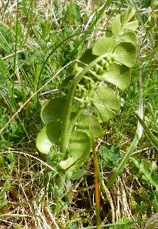 | 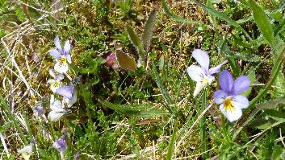 | 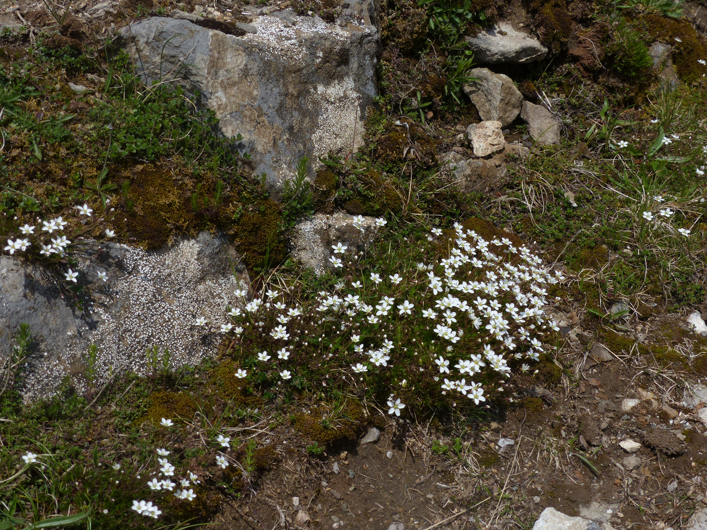
Moonwort | Mountain Pansy | Spring sandwort

The plants all have difference preferences for altitude, moisture and slope, etc.

One example is Nenthead smeltmill which was mined for lead between 1750 and 1890. At the same time the climate was cold and wet, so the river braided and flooded. It was then mined for zinc between 1890 and 1920. From 1900 to 1960 many spoil heaps were reworked and reclaimed.

The habitat is a man-made habitat of short grassland and lichen (as many as 30 per sq metre) areas reverting to woodland. With myxomatosis from 1955 onwards, some areas are being taken over by scrub. It is a rare habitat, with approximately 47ha in the N Pennines, from a UK total of approx. 93ha. The British communities are unique in the world and the Pennine communities are unique to Britain. The S Tyne / Allen and its tributaries / Main Tyne calaminarian grasslands are the most extensive, structurally varied and species-rich examples of riverine calaminarian grassland in the UK – because of the region’s rich heritage of lead mining.

Some of the sites are also SSSIs and SACs – but there are many sites, some of the undesignated ones are of as good quality (or better) than the designated sites. Dune helleborine is a rare flower found on the metalliferous soils under birch – possibly the Tyne helleborine is a separate species.

The Tyne Catchment Plan includes action C42 – the spoil stabilisation trials at Nenthead.

Northumberland Wildlife Trust have a project called “Save Our Magnificent Meadows” which is doing scrub clearance and also soil scraping / turf scraping on some sites. It takes time to see the results of this type of work. The calaminarian grasslands are best visited in June or July. Action: possible idea for a partnership site visit next summer.

The sites can’t be “re-contaminated” obviously, so long-term their future is a little debateable. The Water Framework Directive works towards all waterbodies being in good ecological status, yet the Habitats Directive works towards protecting the SSSIs and the SACs.

- The partnership discussed the recent floods and the impact this may have had on the calaminarian grassland sites. The sites are being assessed for flood impacts
- Tyne Rivers Trust has a done a lot of work on how the metals in spoil heaps are mobilised and how fine sediment gets into the system
- Fragments of calaminarian grassland are believed to be in the Tyne and Wear area, a helleborine was found at a housing site in Stella.
- There was a discussion about the impact on the Port of Tyne and the contaminated sediment

Presentation – Hexham Fish Pass / TRT Volunteer Co-ordinator
Tyne Rivers Trust has been planning the build of Hexham Fish Pass for 10 years. When the Tyne Tunnel was being planned, the proposal to dredge the area (over two fish migration seasons) and drop the tunnel into the area (rather than tunnel through rock) caused concern for upstream fisheries interests. The Integrated Transport Authority set aside mitigation for upstream works to help fish, including Hexham Fish Pass. This led to the establishment of the Tyne Rivers Trust.

Hexham Bridge has been a formidable obstacle for fish for many years, which draw large crowds every autumn at the peak season. The project has been extremely complex – the bridge itself is a Scheduled Ancient Monument on an unstable river bed. A design had to be developed that would cope with a wide range of flows and was not drilled into the bridge footings. The design was drawn up 3 years ago and was about to proceed to planning permission, when it was put on hold following proposals for a hydro scheme by Hexham Community Partnership.

Northumberland County Council have been an excellent partner in the scheme; they built the fish pass this summer and there are plans for an eel pass in 2016 to complement the fish pass. The design consists of a lower ramp, a resting pool and an upper ramp.

In October (peak migration season for salmon and trout) the fish gather in the large pool below the bridge, waiting for the right flows to attempt the jump. This can leave them vulnerable to disease (as they are grouped closely together) and stress. The fish pass will make a big difference for fish in the South Tyne and North Tyne.

The other piece of news from the TRT is successful funding from the HLF “Our Heritage” fund to employ a volunteer co-ordinator (part time, 2 years). Thank you to all the partners who supplied their support and project development ideas. TRT already has River Watch groups, established around 2008, although they tend to be limited to working in their own local area, and tend to be mostly retired people. The aim is to open that up to a wider range of people, (e.g. young people, student projects) activities and geographical areas.
In the long term this post would ideally become permanent.

Ideas from the Tyne Catchment Partnership are welcome (in terms or areas to work in, tasks, opportunities for joint working).
- Northumberland Wildlife Trust would welcome joint tasks in urban areas and the opportunity to bring urban volunteers into the upper catchments. (Although some urban streams are inaccessible or dangerous for volunteers).
- Project ideas with local people include watercourse-friendly gardening.
- Himalayan Balsam on the River Team
- Working on Lamesley Pastures site and Blaydon Burn – there are no volunteer inputs on the Blaydon Burn now
- Make contact with Jane Calvert in Gateshead Council
- Work with the Clean Tyne group
- Rain Gardens

A general discussion about Invasive Non-Native Species followed on – about:
- Local volunteer groups focus on a favourite site for recreation (e.g. picnic site, recreation site) but a bigger, strategic view is needed. Stocksfield group have done really well focusing on Stocksfield Burn rather than the Main Tyne River.
- INNS includes Giant Hogweed – a new invader on the Tyne, which needs a concerted effort. Thanks to Don Atkinson and Jim Cokhill for inputting ideas to Susan on this topic. Tees Rivers Trust has found funding for the INNS co-ordinator because Giant Hogweed is such a dangerous plant so the local councils have contributed.
- The need for a “media event” (to raise the profile) around a major week for co-ordinated action on INNS in partnership e.g. with the Headwaters group (where there has been discussion about a ‘frontline’ or concentrating on 1 species)
- A previous funding bid to Big Lottery (Our Environment, Our Future) was not successful.
- On the topic of Himalayan Balsam, Monique mentioned a test project in the Till catchment relating to rust-fungus as a biological control.

The future of the Tyne Catchment Partnership – discussion paper circulated

Tyne Rivers Trust, as hosts for the partnership, have always sought feedback from partnership members – and this has always been positive. In the light of no guarantee for future funding for hosting, and Defra’s wish for catchment partnerships to become self-sustaining, this discussion paper has been put together. The future will be challenging.

A formal structure was proposed at the first partnership meeting in May 2014 but this was not taken up at the time.

The host funding for 2015/16 is £15k. This pays for 1 day a week of a co-ordinator as well as a small amount of Susan’s time. We have had many successes working together on a catchment (be it waterbody or river) scale. For example, the Ouseburn project, which is a good model to roll out. Partners like Northumbrian Water Group are keen for case studies that illustrate the benefits of partnership working, with tangible achievements.

The gap analysis came to the conclusion that the main issues for the Tyne catchment not covered by other programmes or partnership are the metals / minewaters issue, and the difficult urban complex waterbodies. From Hugh Potter’s presentation in March 2015 at Howdon, it is clear that the metals / minewaters issue is covered by a long-term plan / programme. There remains a need for co-ordination in the urban waterbodies, which was the proposed focus in the discussion paper.

The discussion was for the whole partnership, and the decision is our joint (whole partnership’s) responsibility.

Some responses were sent by email, these were read out (and are listed at the end of these minutes).

- Jim Cokhill advised that there is a danger from removing ourselves from opportunities that may arise over a 12 – 18 month period in the uplands
- Northumberland Wildlife Trust were also concerned about increased competition for funding opportunities in a limited area and advised to keep the Tyne Catchment Partnership broad
- Graeme Hull urged us to find some common priorities / common objectives. He expressed the view that the Tyne Catchment Partnership should be catchment wide and inclusive, recognising all work to improve the water environment and constantly seeking opportunities to do more. The circulated paper combines proposals for the Tyne Catchment Partnership and the proposed focus of work or an Action Plan for 2016/17. As described the proposal may be misinterpreted as restricting the ‘Tyne Catchment Partnership’ to only the urban geographical areas and activities described. The Partnership needs to decide the arrangements for the future organisation and governance of the Tyne Catchment Partnership beyond March 2015 in order to decide on and deliver a plan of action for 2016/17. Is our objective to oversee the delivery of the Tyne Catchment Plan? Susan reminded the partnership that the development of the plan was undertaken in only 8½ months and so technically would have needed more development / strategic input to make it into a focused ‘action’ or ‘activity’ plan.
- Peter Bell suggested that our objective is “Integrating the water environment at a catchment scale”. Blaydon Burn he felt is another example of genuine added value, adding a focus to that area, which would not have been achieved. TRT is ideally placed to help at a catchment scale. Lynne added later that the Haltwhistle Burn project is another perfect example of partnership work, around catchment restoration and slowing-the-flow, with local communities. People take ownership of projects like this, and take an interest e.g. in non-native species removal. A ‘gap’ will open up here when the project finishes.
- In terms of future funding opportunities, we are stronger as a partnership if the preferences for EA / DEFRA to fund partnership projects continues. But partners themselves can’t fund the ongoing partnership. The default host for a catchment partnership would then have to be the EA. We don’t want to see the partnership fail but need to find a way to make it work. There is a need for us to explain why we exist and what we are / what we aim to achieve.
- In local government there are going to be more cuts, so less delivery capability, fewer specialists, and remaining staff will be tied to statutory requirements. Projects need to be delivered by different mechanisms. The Tyne Catchment Partnership enables local authorities to link with charities / trusts, who sometimes have more flexible funding opportunities.
- The Three Rivers LNP has had success because it speaks with a single voice, it is a single mechanism of contact, where one single partner would not be as successful.

- The following Vision for the Tyne Catchment Partnership was suggested:

Working together to benefit the people, wildlife and habitats of the Tyne Catchment’s river environments.

Five main objectives of the Tyne Catchment Partnership were also suggested:
- Promoting and celebrating partners’ achievements and successes
- Identifying and grasping needs and opportunities to work together (as organisations) for better outcomes for the River Tyne and its people
- Speaking with a single voice where partners’ interests in managing and improving the River Tyne overlap
- Grasping opportunities that projects deliver multiple benefits for the benefit of the River Tyne
- Using resources to best effect and coordinating activities on a catchment and sub-catchment level.

Our common objective therefore includes a combination of the water environment for people and for the natural environment. It includes an element of multi-functional benefits and green infrastructure. Of seizing opportunities to work together and make the best use of resources. We are rooted in the water environment to avoid overlap with other partnerships.

- Already in this urban area we have the Land of Oak and Iron, the Ouseburn Evidence & Measures / River Restoration projects, the IAMP on the Don and flood alleviation on the Team. Are all these projects enough? What about a focus on future development and on climate change
- What can we all, jointly, do to deliver projects – to keep us around the table?
- Michelle suggested doing the gap analysis at a more local level, drilling down to the rivers. A series of sub-catchments, bringing together the relevant partners, plus other stakeholders. This should be a light-touch review with a holistic overview.
- The Ouseburn Evidence & Measures project was mentioned. Jim Cokhill agreed that there is a need to collate the local data on the Don. Note : The Medium Term Plan included rolling out the E&M approach to the Don and the Team. The Ouseburn has moved into the stage of “who is taking forward the actions”. There is perhaps a problem of on-going revenue costs. Should the Tyne Catchment Partnership work up a funding bid e.g. Landscape Partnership (or another?), to take Evidence & Measures type work further?

It was agreed that each partner would send to tynecatchment@tyneriverstrust.org or to Susan Mackirdy their project priorities for both a short term (12 – 18 months) and longer term (18 months – 10 years) timescale (not high level) before the next meeting. Action: All. Post-meeting note: Graeme Hull sent ‘priority places’ for the Ouseburn, Team and the Don. These have been published on the Tyne Catchment Partnership website under ‘meetings of the partnership’.

Note: feedback about the Tyne Catchment Partnership hosting is welcome, contact Susan Mackirdy at any time.

News / updates around the table
- Graeme Hull updated on the EA’s Grant-In-Aid Medium Term Plan. Thank you to all the partners who worked up project ideas. These are now being sifted on priority waterbodies, and working on joining projects where possible / eliminating duplication. Hopefully the WFD medium term plan will move to a 6 year cycle. Two funding scenarios are being modelled and more detail will be circulated as soon as it is confirmed, hopefully early in the New Year. Partners will need to work up projects that would start delivery in 2016 / 2017 in more detail.
- Lynne Dunleavy mentioned that the North Pennine Dales LEADER programme now includes parts of rural Gateshead, Lamesley and up to the Tyne across the South to near Haltwhistle. Lynne will circulate leaflets when these are made public. Funding applications for the new area (especially rural Gateshead) would be an excellent opportunity. Work areas include farming and forestry, local (micro) businesses, rural tourism and rural services. To see the map, go to www.magic.gov.uk/MagicMap.aspx and click on administrative geographies, then click on other administrative boundaries, then click on rural development fund :

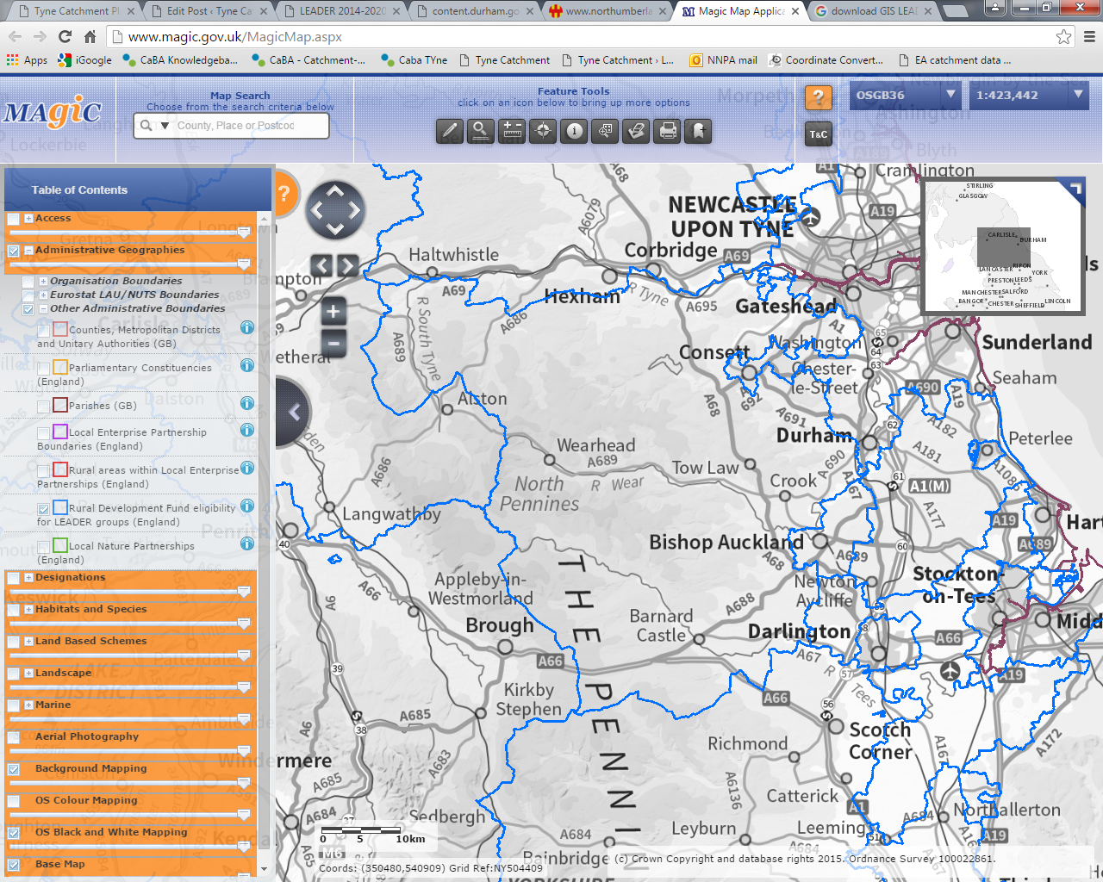

- Sarah Beeson from Northumberland Wildlife Trust updated on the CPAF project. The floating islands are now complete. The Newburn / Sugley Dene tributary ones were towed with boats and anchored to the bed with steel cables / cement slabs. The Wallsend ones are anchored to the sides with wires. Bird netting has been added to stop swans. The Branch Out fund was used last year for the Ouseburn ones.
- Northumberland Wildlife Trust has decided not to proceed with the Living Waterways project owing to the timeframe – completing the research, planning and practical work in just a few months. It felt it was becoming more of a risk than an opportunity. The project was for other habitat improvement projects have been on the Wallsend Burn, Throckley, and Longbenton. The news of this has not yet been circulated to the partnership. Action: Abi – follow this up with Graeme Hull (he left the meeting at the break). De-culverting the Bede Burn is another Living Waterways project with S Tyneside – the signing of the agreement has probably been delayed because of confusions with planning permission and flooding consents. Durham Wildlife Trust have changed the working of their agreement so there was no requirement to deliver.
- Flooding – Otterburn – rapid response catchments – Nick Brodin has been informed. Bellingham next week
- A Freshwater Pearl Mussel steering group will take place later this week. A bid will be going in to the Esmée Fairburn foundation for a feasibility study, with the hope of using the Kielder hatchery as the Ark site for the pearl mussel in this area. (They are currently kept at Windermere and are not doing too well, possibly because of water temperature). The aim would be for Pearl mussels to be transplanted back into the river at about age 5, when they become less vulnerable to pollution and siltation of gravel.
- Jim Cokhill reported on news from the Three Rivers LNP. It is merging with the Northumberland Lowlands and Coasts LNP to form a new “North East LNP”. Ben Lamb used to come to the Three Rivers LNP. Susan asked if there is adequate representation for the new area from catchment partnerships. Jim advised that the new LNP will be meeting in January, and then will be setting up sub-groups e.g. Natural Environment sub-group – the representation will be best there. Action: Abi include an update from both the NE LNP and the NUC LNP on each agenda. The area of the Tyne catchment that is covered in the new LNP includes
  - In Redesdale : Area around Otterburn / East and W Woodburn / Ridsdale
  - In the N Tyne : Area around Bellingham / Redesmouth / Wark / Hallington Reservoirs / Humshaugh / Acomb
  - In the S Tyne : a short 2.5 km section from Waters Meet and around Warden
  - In the Main Tyne : Hexham / Corbridge / Stocksfield / Prudhoe / Tyne & Wear, The Don and the Team
  - In the Derwent : all the area down river of Allensford and Consett
- River Team Flood Alleviation and Water Meadows Project: The Environment Agency has commissioned Capita to undertaken an appraisal of the flood mitigation options necessary to deliver the project. This will combine protection of the Trading Estate from flooding with wider environmental benefits, including an expansion of the wetland nature reserve at Lamesley Pastures. This appraisal will be completed early in the New Year, but it is already clear that the overall cost of the project will be higher than originally anticipated. With this in mind, a European funding bid will be made in 2016, matching the Flood and Coastal Risk Management Grant in Aid and other funding, which has already been secured.
- The Land of Oak and Iron HLF Landscape Partnership has reached stage 2. This is good news for Shibdon Meadow (wet grassland site). It is hoped to obtain the rest of the site from the co-op. Another site in the Action Plan is the Lintzford Weir fish easement. Other projects include non-native species removal. The 4-year delivery phase will start in 2016. More information is also on Gateshead Council’s website, here.
- Revitalising Redesdale Landscape Partnership bid Phase 1 was successful. Led by Natural England, the project will develop proposals for improvements to natural, cultural and built heritage. Much of the natural heritage work will focus on the river environment and particularly the Freshwater Pearl Mussel. The stage 1 grant is for £115k to develop a bid for £1,8m for submission in June 2017, for the project to run 2018 – 2023. A board is currently being established, including representatives from the many partners and the community. A River Improvement Plan will be part of stage 1.
- The Coastal Group – this stretches from Whitburn / S Shields to Berwick upon Tweed. The need for the coastal group was identified at the joint Tyne / Northumberland Rivers Trusts’ forum held in early spring 2014. Its remit is evolving to include the tidal river and the estuary, which is important for the Tyne (26km are tidal, as far as Wylam). They meet quarterly. Action: Susan to circulate the minutes and to seek input from partnership members for up-coming meetings.
- Ouseburn briefing note: This is very nearly ready for final release. It is hoped to use the template for other partnership case-studies (anybody with ideas contact Clare Deasy). Action: Abi circulate the final briefing note / put up on the Tyne Catchment website when it is ready
- Monique Speksnyder asked the partnership to feed through her ideas for farms that need water quality management, with the new stewardship in mind.
- Also Monique mentioned the Tesco plastic bag fund is looking for local projects to fund (around £5k - £8k). The fund is being administered by Groundwork. Action: Abi circulate the links.

The link to the Tesco carrier bag tax fund is: www.groundwork.org.uk/Sites/tescocommunityscheme. The TRT recently received information via the umbrella body The Rivers Trust about the scheme being undersubscribed – the key points are below:

At the end of the first funding round it looks like Tesco / Groundwork will have more money to distribute than projects to distribute it to. The Rivers Trust umbrella body are keeping the window open and trying to remove some barriers that they know have put people off. They’re picking up that a lot of local authorities are putting a blanket moratorium on signing off landowner permission worried about future maintenance bills. So, anybody with land under their control is at the top of the list, to submit applications.

There’s no limit on how many applications can be submitted as all of the assessment is based on Tesco’s ‘regions’ – of which there are 427 – so each area could probably feature in half a dozen different regions if they had suitable sites. In order to maximise numbers a stripped down process has been introduced, which involves a simple expression of interest form to get people in the system before 11th Dec. To follow up with more information after Christmas.

Applicants can apply for up to £12k of capital funding, there is no match funding requirement, and applications have to be in by the 11th December.

Media stories
Suggested item(s) for a joint partnership media release are around Fellgate, SUDs in schools, ponds, flood alleviation project. Or around Haltwhistle and how well it is bearing up after the flooding (links here to Eleanor’s project).

Susan suggested setting up a twitter / facebook account for the catchment partnership. Action: Susan / Kirsty

Date of next meeting
25th Feb 2016.
Any suggestions for a venue or a presentation, please contact tynecatchment@tyneriverstrust.org – thank you!

Email responses to the discussion paper

- CLA: is supportive, so long as opportunities to carry out work in the rural environment are grabbed (either by the TCP or other partnerships/organisations), including any natural flood management work that may result from this weekend’s floods.
- Northern Farmers and Landowners Group: I found the paper a little confusing. On page 1, I thought that the thrust of it would be how the Partnership would proceed as a body in 2016 with no direct funding. However, this line of thought peters out and page 2 begins with the discussion of the “Vision” and what the partnership is going to do in 2016. Surely its very existence needs to be sorted before its work programme is discussed?
- John Robinson (Newcastle City Council): Think it’s important to keep a catchment based overview. On the basis that water travels downhill I suspect everything that’s good bad or indifferent ends up at the river mouth so we all have an interest in it. If it’s a healthy river by that point then I feel we are doing a good job. If that’s sustainable even better.
  - Current situation
    - Sounds as though the Pennine side of it is under control by others so I wouldn’t have a problem of leaving it like that but being kept up to date about progress/potential schemes.
    - It seems that the catchment is well controlled by dams with timetables for releases from Kielder for example. Can we say the river is well managed from the flood risk point of view.
  - Future
    - Some form of comprehensive programme of works within the catchment must be close at hand with:
      - The Trust’s proposed programme
      - EA’s MTP including river and surface water flood risk management projects and water quality related schemes.
      - NW have developed a prioritised list of schemes across their area.
      - Local Authority New Developments
    - With my engineer’s hat on I am sometimes unaware of what the bio-diversity world is aiming to achieve but am aware that we must get multiple benefits from any scheme we progress.
    - A GIS format for sharing data about our various intentions (I know easier said than done!)
    - Need a balance between flora/fauna and humans that will include landowners and local authorities.
    - Keeping the group functioning provides an opportunity to bring together several disciplines that may not normally meet but sometimes you do see the same people at different meetings. How can this best be done?
    - I notice that only sub-catchments are looked after in some areas so focussing on the urban areas wouldn’t necessarily be a break from tradition.
    - Have we a long term view of how water quality will improve, I suspect we need to look at decades for some of the pollutants locked in the silt for example?
    - As far as I am aware river dredging is minimal these days but it needs to be considered if it removes contaminated silt(?)
    - Perhaps a limited steering group made up of Trust/EA/NWL/Flood Risk Partnership/Natural England/ A N Others?
  - Opportunities
    - Don’t forget health based opportunities such as opening cycle routes/footpaths along rivers and watercourses.
    - Water quality improvement schemes in the uplands will benefit the whole river in some form or other so as long as they are sustainable I wouldn’t have a problem supporting them.
    - If you focus on the Lower Tyne then the Tyne Wear Flood Risk partnership already exists. It meets quarterly and brings together the EA/NW and LLFA’s. It’s a potential partner in managing the Lower Tyne sub-catchment.
    - If the trusts set up is revised could the RFCC support it? NW potential funding source?
    - Run Water Ranger type service in the catchment?
    - If we don’t have a way of bringing together all strategic stakeholders in the catchment then I don’t see how we can do our jobs to obtain as many benefits as we can with the limited funding we have. We must be working together.

E.g. 6 sites that make up “Tyne & Allen River Gravels”
E.g. 5 sites that make up the “Tyne & Nent SAC” near Alston, Blagill, Nentberry Haggs, Bentyfield Mine, and Flinty Mines / Dowgang Hush
Although 98% of water lands on the land, so we are not limited to the riparian environment
Part of the Don-from-source-to-tidal-limit waterbody
There are 6 rapid response catchments in the Tyne : Acomb (Red Burn), Bellingham, Greenhead (Tipalt Burn), Kielder (Kielder Burn, River N Tyne from source to Lewis Burn, Butteryhaugh area), Otterburn, Stocksfield and Wark (Dean Burn). More info here

